Project Development Phase
Functional & Performance Testing

Date | 06 February 2026
Team ID | SWTID-2026-7310
Project Name | Auto Ticket Classification using Flow Designer
Maximum Marks

Functional & Performance Testing:
The team verified the Flow Designer automation end to end on the ServiceNow instance. Results below come from the executed test scenarios.
S.No. | Parameter | Values | Screenshot
 | Automation Summary | ServiceNow automation 'Auto Classify School IT Tickets' (Flow Designer) on the custom table Incident WorkFlow (u_incident_workflow). Trigger: Record Created with Category is empty. If / Else-If branches on Short description set Category and Subcategory, then Send Email notifies the caller. | 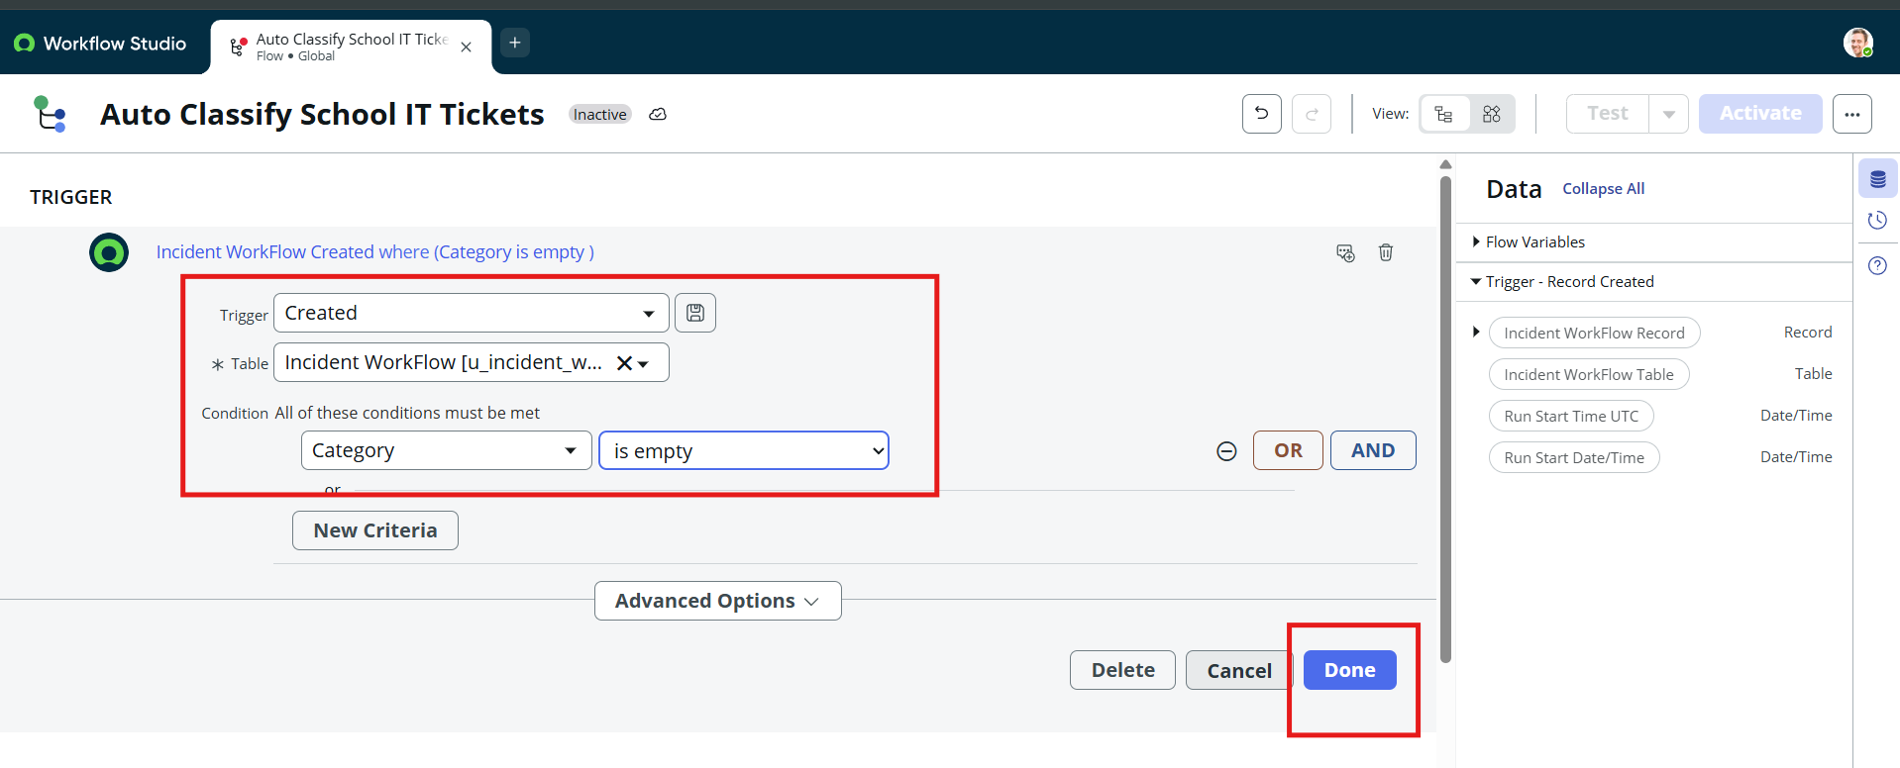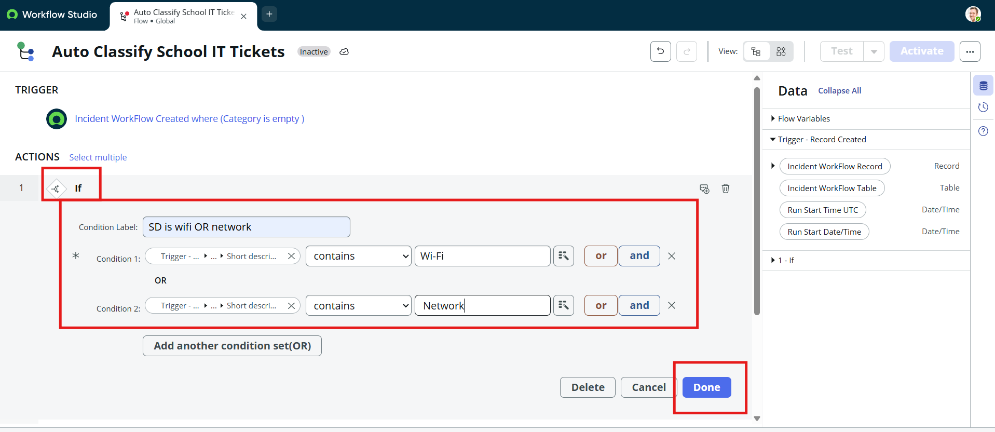
 | Classification Accuracy | Scenarios executed: 2 (Network / Wi-Fi, Projector)  Correct classification: 2 of 2 (100%)  Note: Password and Slow Computer branches are configured; execute and record them to extend this result. | - 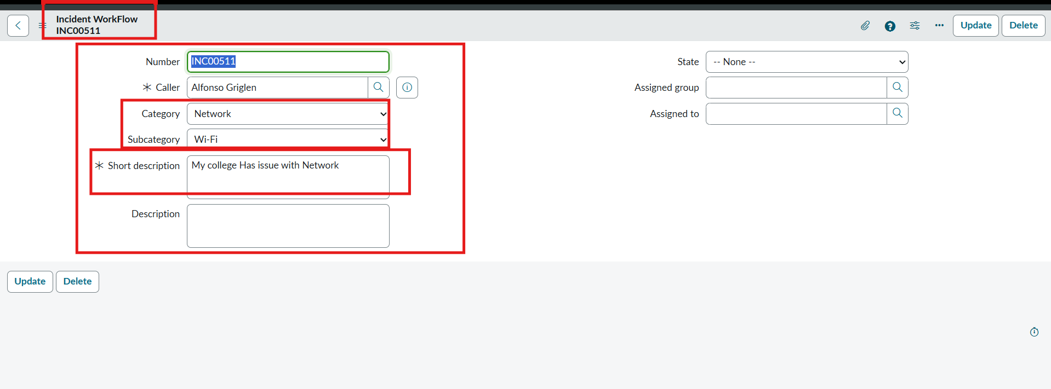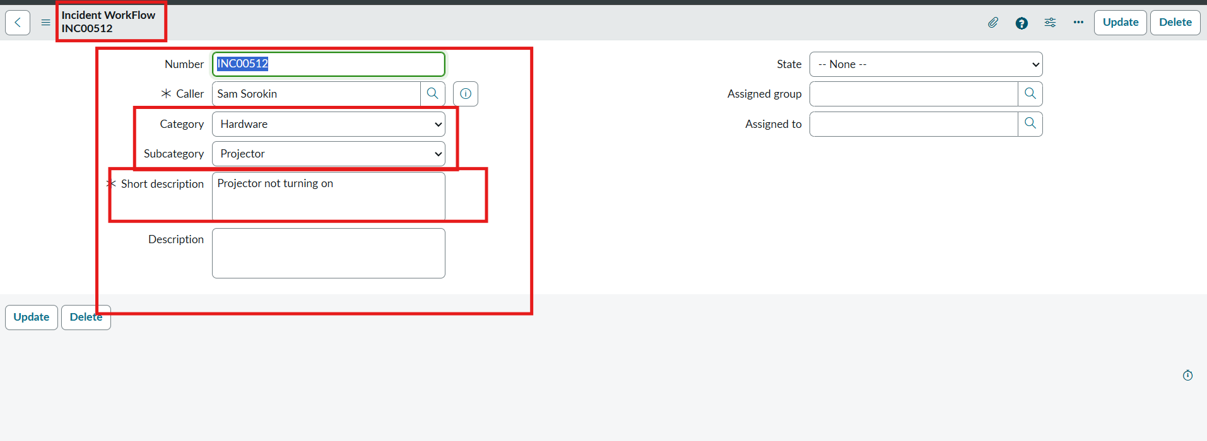
3. | Data Validation | Auto-number generated without duplication (INC00511, INC00512)  Caller reference resolved to a user record  Category and Subcategory stored accurately after save and reload
3. | Email Notification | Email 'Your Request for the issue has been submitted.' found in System Logs > Emails for the callers; Preview Email shows the confirmation message. | 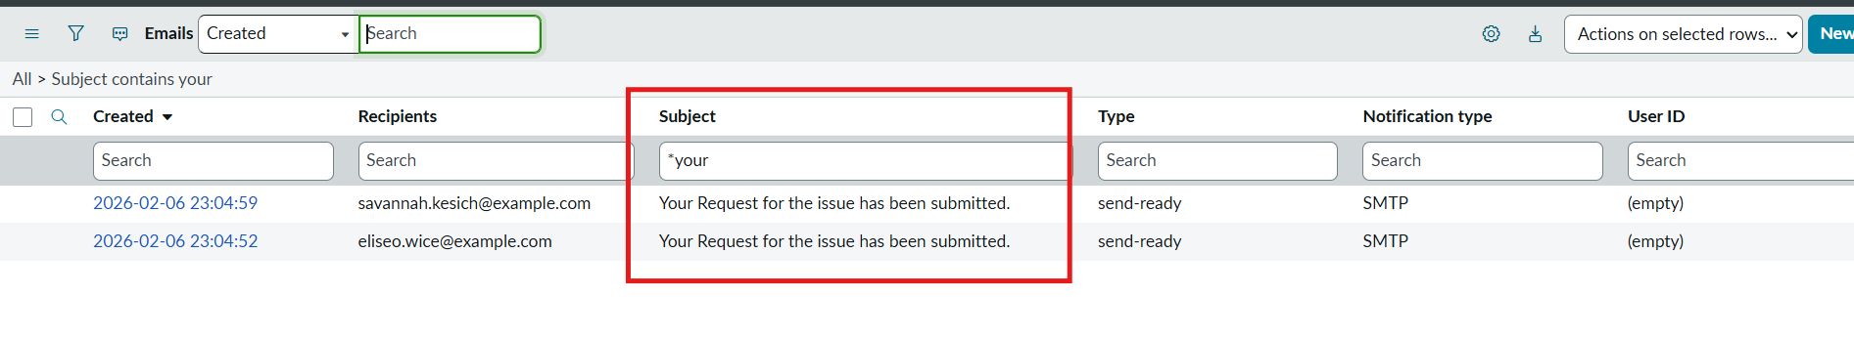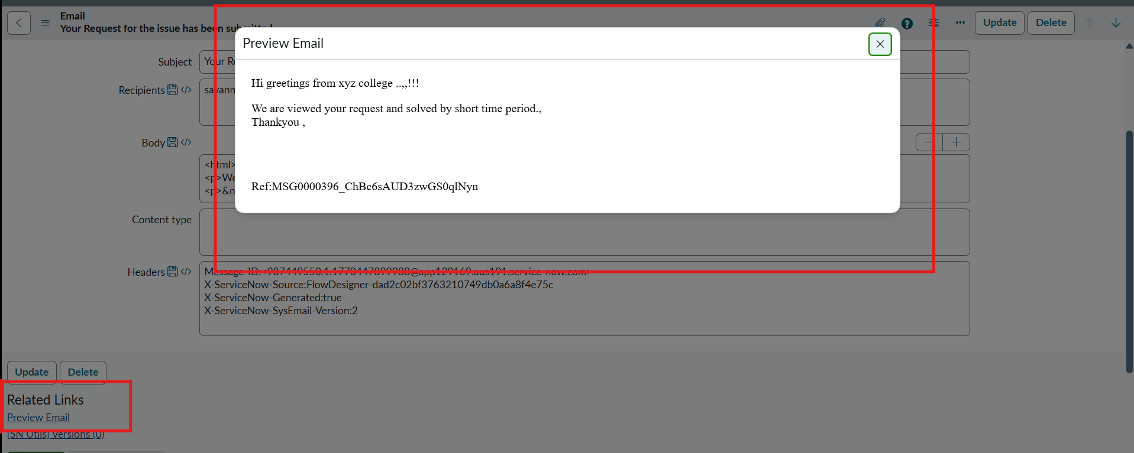
3. | Deployment | Project Update Set set to Complete and exported to XML (182 KB). | 